PFP - Labwork 02

Q1 (2.5 marks). Write a program that performs the following tasks:
- Create a function with variable length of arguments
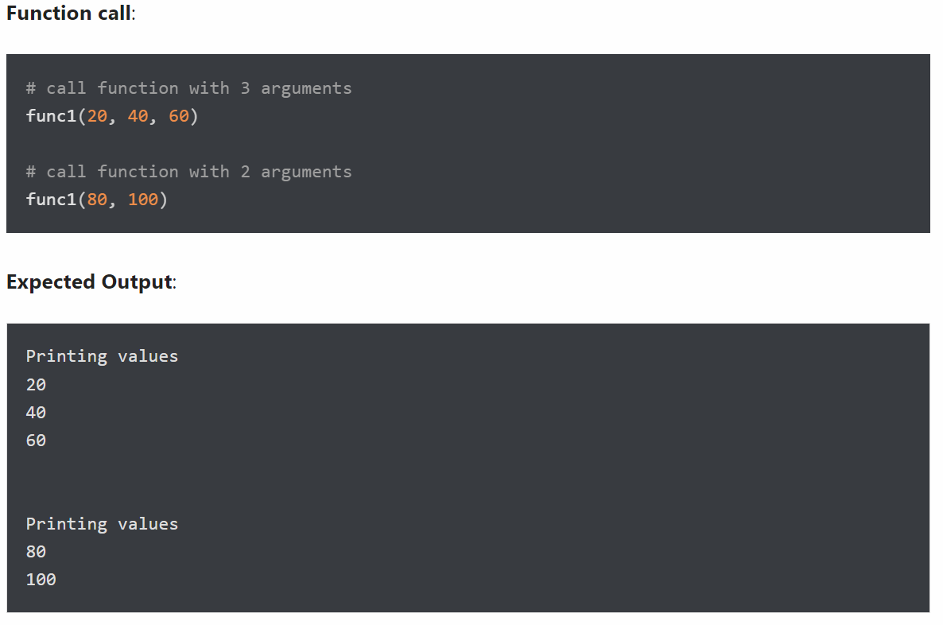
- Return multiple values from a function
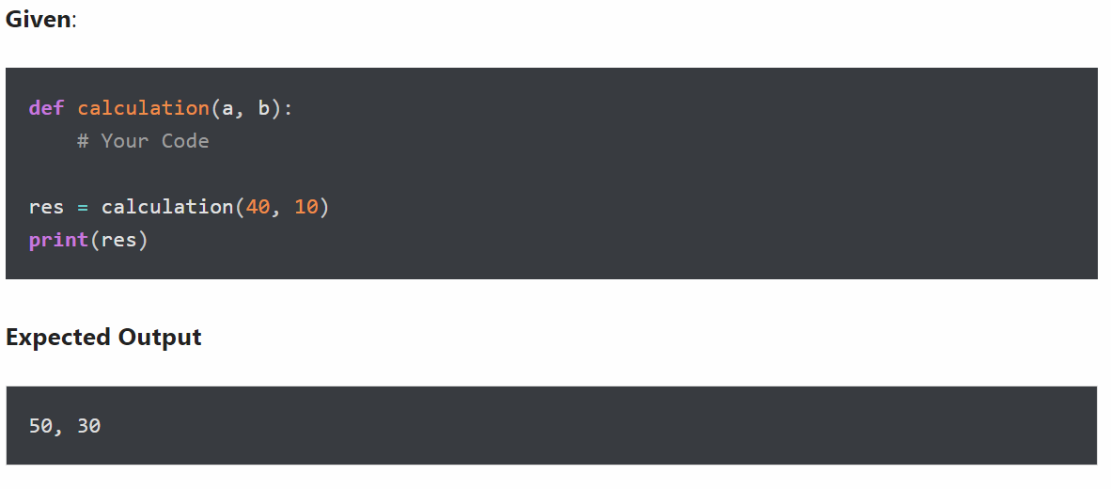
Q2 (2.5 marks). Write a program to accept 2 integer numbers m and n, then:
- Create a function with default argument
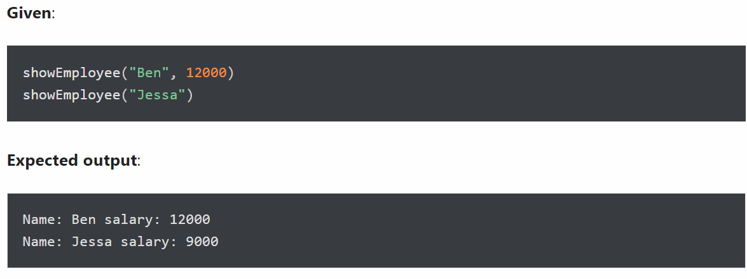
- Create an inner function to calculate the addition in the following way
- Create an outer function that will accept two parameters, a and b
- Create an inner function inside an outer function that will calculate the addition of a and b
- At last, an outer function will add 5 into addition and return it
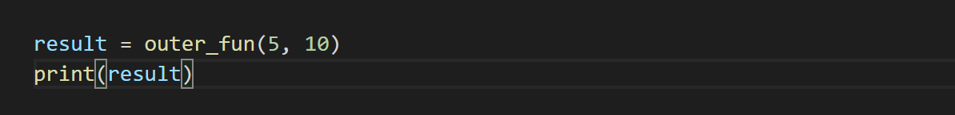

Q3 (2.5 marks). Write a program that performs the following tasks:
- Create a recursive function
Write a program to create a recursive function to calculate the sum of numbers from 0 to 10.
A recursive function is a function that calls itself, again and again.
- Assign a different name to function and call it through the new name
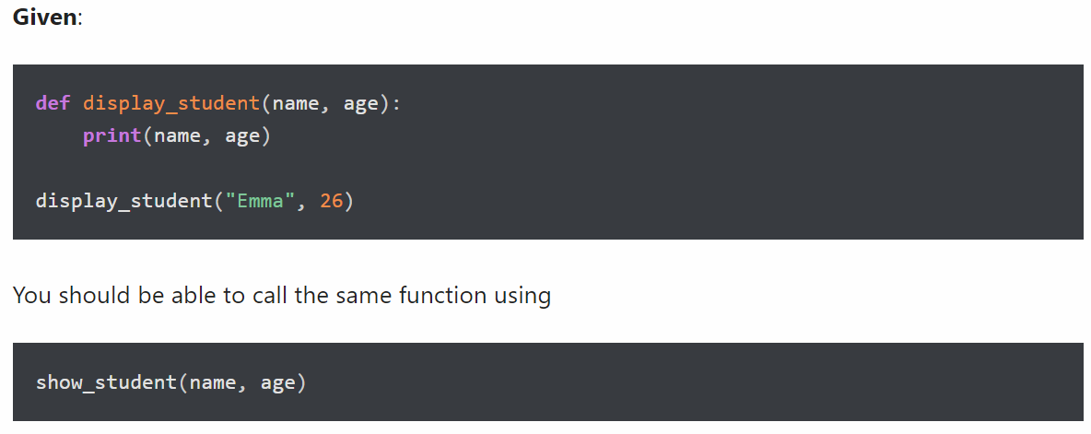
Output:

Q4 (2.5 marks). Write a program that performs the following tasks:
- Check Palindrome Number
A palindrome number is a number that is same after reverse. For example 545, is the palindrome numbers
- Find the largest item from a given list
